



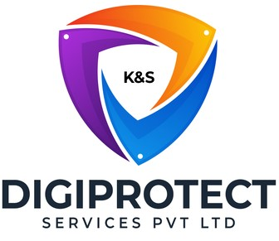

INITIAL
ASSESSMENT
REPORT

DATE:4th July 2024
Secretarial
VERSION: 1.2

Document History
Document version | Remarks | Submitted  By | Submission  Date | Approved BY | Approval  Date
1.0 | First Draft | k&S Digiprotect | 5th June 2024
1.1 | Second Draft | k&S Digiprotect | 26th June 2024
1.2 | Third Draft | k&S Digiprotect | 4th July 2024

K&S Digiprotect Services Pvt. Ltd.
Date of Discussion: Date of Release:
Version: 1.0
Date of Release: 15th April 2024

Table of Contents
Introduction 4
Objectives 4
General Information 5
SPOC Information 5
Department Hierarchy* 6
Observations 7
Data Flow Diagram (DFD) 10
Data Mapping and Inventory 11
Recommendations 13
Conclusion 14
Appendices 15
Appendix A 15

Introduction
India Shelter’s Secretarial Department is essential for their operations, ensuring robust corporate governance and regulatory compliance. They meticulously prepare and manage board and General Committee meetings, maintain comprehensive corporate records, and facilitate transparent communication among stakeholders. The department oversees statutory compliance, regulatory filings, and licensing processes, ensuring ISFC meets all legal obligations. They also safeguard sensitive information through rigorous records management and supports corporate restructuring activities, underpinning the organization's integrity and sustainable growth.
This report encapsulates critical insights for As-Is study, derived from the initial interview conducted with the Secretarial Department of India Shelter Finance Corporation Limited (ISFC) for the implementation of ISO/IEC 27001:2022 and compliance with the Digital Personal Data Protection Act (DPDPA).
The overarching objectives of this interview were dual fold: first, to gain an understanding of the departmental structure, and second, to delve into the core operational processes of the Secretarial Department. Additionally, the interview aimed to assess the existing information security practices, focusing on evaluating adherence to DPDPA requirements and the readiness for ISO/IEC 27001:2022 implementation.
By delving into the details of the department's organizational setup, operational workflows, and data handling procedures, this report aims to identify both the strengths and areas of improvement in information security management and DPDPA compliance within the department.

Objectives
- Understand the departmental hierarchy and reporting structure
- Learn the existing processes of ISFC’s Secretarial Department
- Mapping of existing processes with documented processes
- Offer recommendations to optimize the existing processes

General Information
Organization Name | India Shelter Finance Corporation Limited
Department Name | Secretarial Department
Date of the Assessment | 2nd May 2024
Location | Basement, India Shelter HQ, Gurugram
Meeting Duration | 30 minutes
Attendees (ISFC) | Mukti Chaplot, Alka, Shivani, Sunil Kumar Sharma
Attendees (Digiprotect) | Lalit Mohan Joshi, Adhita Razdan

SPOC Information
Project SPOC: Dheeraj Yadav
Contact Information:
Email ID: dheeraj.yadav@indiashelter.in

Project Coordinator: Sunil Kumar Sharma
Contact Information:
Email ID: sunil.sharma2@indiashelter.in

Department SPOC: Mukti Chaplot
Contact Information:
Email ID: mukti.chaplot@indiashelter.in

Department Hierarchy*

* As informed during the meeting

Observations
S. No | Key Activities | Observations and Asks | Remarks
 | Board and General Committee Meetings  - Preparation and Facilitation  - Agendas are meticulously prepared, incorporating key discussion points and action items.  - Minutes of meetings are drafted meticulously, capturing discussions, decisions, and action points.  - Logistics Management  - Arrangements are made for the smooth conduct of shareholder meetings.  - Attendee coordination, and provision of necessary materials is also organized by this department. | - Yes, customer PI data is accessed on need-to-know basis  - Holding of Board Meetings is governed by the provisions of the Companies Act, 2013 and calendar is maintained by the team.  - Secretarial team has onboarded virtual meeting - Dess Digital meetings.  - Q-1 meeting was held via the same.  - Agenda's are shared via the above said system | - ISFC to confirm whether or not they access Personal information of Customers and business case for accessing the same. – Clarified and recorded in Observations and Asks  - No SoPs in place for Board meetings. - Clarified and recorded in Observations and Asks
Corporate Governance
  - Implementation of Governance Practices
    - Corporate governance principles are diligently implemented to foster transparency, accountability, and fairness.
    - Policies and procedures are reviewed and updated to align with regulatory requirements and industry best practices.
  - Record Maintenance and Disclosure
    - Comprehensive records are maintained, including board resolutions, shareholder communications, and regulatory filings.
    - Disclosure of relevant information to stakeholders is also done by this department.
 | Company Secretarial Functions  - Statutory Compliance  - Statutory registers meticulously maintained, ensuring compliance with the Companies Act and other relevant legislation.  - Corporate records updated regularly to reflect changes in shareholding, directorship, and other corporate matters.  - Regulatory Compliance  - The department handles preparation and submission of regulatory filings to various authorities, including the SEBI / MCA / ROC / NSE / BSE / CDSL / NSDL. |  | - Bank details, Aadhar Card, Pan Card, and Passport of Directors is shared with Treasury department as well.  - Permission from CS is obtained to share the details. In some cases, Director permission is also sought.  - Legacy data of Directors is available as Physical documents and kept safely under the custody of the Company Secretary
Licensing and Regulatory Approvals
  - Licensing Process
    - Assistance is provided during the licensing process, which includes preparation of applications and liaison with regulatory authorities.
    - Renewal of licenses and approvals is also managed by respective teams in consultation with Compliance team
  - Regulatory Liaison
    - Effective communication and collaboration with regulatory bodies is maintained to address queries, resolve issues, and obtain necessary approvals.
 | Corporate Records Management  - Records Maintenance  - Accurate and up-to-date corporate records are maintained, including documentation related to incorporation, shareholding, and board decisions.  - Document Security  - Physical documents are stored under lock and key mechanism to safeguard against loss, theft, or unauthorized access, ensuring data integrity and confidentiality.  - The Fintrack app contains relevant information about CEOs, Managing Directors (MDs), and two levels below (department heads, project managers, or senior team leads)  - Agent registers and transfer processes are managed by KFIN, with both physical and online compliance checks conducted regularly. |  | - Digital Documents are not stored in encrypted format.

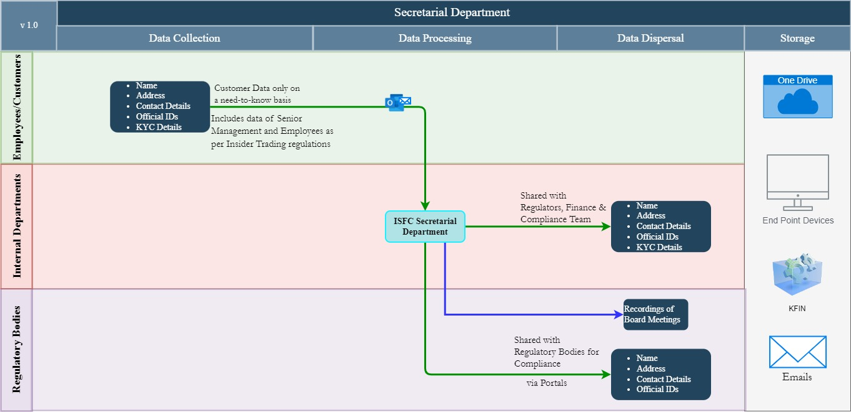
Data Flow Diagram (DFD)

Data Mapping and Inventory
S. No | Data Category | Description | Purpose | Data Owner | Storage Location | Data Classification* | Retention Period | Legal Basis
1 | Board Meeting Agendas | Agendas prepared with key discussion points and action items | To guide discussions and decisions during board meetings | Secretarial Department | One Drive/ Emails | Non PII/  Confidential | Permanent | Companies Act, Internal Governance Policies
2 | Minutes of Meetings | Detailed records of discussions, decisions, and action points | Official record of meetings for compliance and reference | Secretarial Department | One Drive/ Emails | Non PII/  Confidential | Permanent | Companies Act, Internal Governance Policies
3 | Shareholder Meeting Arrangements | Details of logistics, coordination, and materials for shareholder meetings | To ensure smooth conduct of shareholder meetings | Secretarial Department | One Drive/ Emails | Non PII/  Restricted | Permanent | Companies Act, Internal Governance Policies
4 | Governance Policies and Procedures | Reviewed and updated policies and procedures | To align with regulatory requirements and best practices | Secretarial Department | One Drive/ Emails | Non PII/  Private | Until superseded | Companies Act, SEBI Guidelines
5 | Board Resolutions | Comprehensive records of board resolutions | Official record of board decisions | Secretarial Department | One Drive/ Emails | Non PII/  Confidential | Permanent | Companies Act
6 | Shareholder Communications | Communications between the company and its shareholders | To inform and engage shareholders | Secretarial Department | One Drive/ Emails | Non PII/  Confidential | 7 years | Companies Act, SEBI Guidelines
7 | Regulatory Filings | Filings submitted to SEBI, MCA, etc. | To ensure regulatory compliance | Secretarial Department | One Drive/ Emails | Non PII/  Confidential | Permanent | RBI, SEBI, MCA Regulations
8 | Licensing Applications | Applications for obtaining necessary licenses and approvals | To operate legally and ensure compliance | Secretarial Department | One Drive/ Emails | Non PII/  Confidential | Permanent | Regulatory Requirements
9 | License Renewal Records | Documentation related to renewal of licenses and approvals | To maintain necessary operational licenses | Secretarial Department | One Drive/ Emails | Non PII/  Confidential | 7 years after expiration | Regulatory Requirements
10 | Regulatory Correspondence | Communications with regulatory bodies | To address queries, resolve issues, and obtain approvals | Secretarial Department | One Drive/ Emails | Non PII/  Confidential | 7 years | Regulatory Requirements
11 | Corporate Records | Documentation related to incorporation, shareholding, and board decisions | For legal compliance and business continuity | Secretarial Department | One Drive/ Emails | Non PII/  Confidential | Permanent | Companies Act
*Refer Appendix A

Recommendations
- Board and Shareholder Meetings
- Utilize secure virtual meeting platforms with end-to-end encryption for online meetings.
- Distribute meeting materials through secure portals with access control and audit trails.
Update – Dess Digital Meetings has been onboarded and 2024 Q1 meeting was held via the same.
- Corporate Governance
- Conduct regular security audits and risk assessments to identify and mitigate potential vulnerabilities in governance practices.
- Implement a robust incident response plan to address any data breaches or security incidents promptly.
- Types of Audits that can be conducted:
  - Data Protection Audits
    - Purpose: To assess the effectiveness of data protection measures and ensure compliance with data protection regulations such as the Digital Personal Data Protection Act, 2023, and relevant guidelines.
    - Scope: Examination of data handling processes, storage practices, encryption methods, and access controls for corporate records and communications.
    - Frequency: Annually or before a new process is incorporated or before a major change to a process is implemented.
    - Process:
      - Evaluate the security of digital records.
      - Assess the effectiveness of encryption and access control mechanisms.
      - Review procedures for data storing, and transmission.

  - Operational Audits
    - Purpose: To evaluate the efficiency and effectiveness of the Secretarial Department’s operations and identify areas for improvement.
    - Scope: Review of processes related to meeting preparation, logistics management, record maintenance, and regulatory liaison.
    - Frequency: Annually or bi-annually.

    - Process:
      - Analyse workflow and process efficiency.
      - Identify bottlenecks or redundancies.
      - Recommend improvements for operational effectiveness.

  - Governance Audits
    - Purpose: To ensure the implementation of best practices in corporate governance and adherence to governance principles.
    - Scope: Review of governance policies, board and shareholder meeting procedures, and stakeholder communications.
    - Frequency: Annually.
    - Process:
      - Evaluate the effectiveness of governance policies and their implementation.
      - Review the documentation and processes for board and shareholder meetings.
      - Evaluate the process for transparent and timely communication with stakeholders.

- Record Maintenance and Disclosure
- Digital Documents should be stored in encrypted format to ensure safety and prevent unauthorized access.

- Company Secretarial Functions
- Implement secure and automated compliance management tools to ensure ongoing adherence to statutory requirements.
- Regularly back up statutory records and corporate data, ensuring off-site storage with encryption.
Update – Compliance management tool onboarded. Timeline for implementation – June 2024.
- Licensing and Regulatory Approvals
- Secure all licensing documentation using encryption and access controls to prevent unauthorized access.

- Implement MFA for Fintrack
  - Enable Multi-Factor Authentication for the Fintrack app to enhance security.
  - Regularly review and update security protocols to protect sensitive information.

Conclusion
The Secretarial Department plays a crucial role in maintaining the integrity, transparency, and regulatory compliance. To further strengthen the department's operations, several recommendations have been identified from an information security and data protection perspective. These include implementing secure document management systems, leveraging encrypted communication channels, conducting regular security audits, and ensuring robust physical and digital security measures for all corporate records.
By adopting these recommendations, the Secretarial Department can enhance its capability to safeguard sensitive information, ensure regulatory compliance, and support the sustainable growth of the organization.
In conclusion, the Secretarial Department's commitment to excellence in corporate governance and compliance, coupled with enhanced information security practices, will continue to be a cornerstone of India Shelter’s success.

Appendices

Appendix A
Data Classification | Definition
Sensitive Data | Information that, if disclosed, altered, or destroyed without authorization, could cause significant harm to an individual, organization, or entity. This often includes financial records, medical information, and PII.
Restricted Data | Highly sensitive data tightly controlled due to legal, regulatory, or contractual requirements. Access is limited to authorized personnel, and any unauthorized disclosure may result in severe consequences.
Private Data | Information considered confidential and intended solely for specific individuals or groups within an organization. It requires protection from unauthorized access to maintain privacy and uphold confidentiality agreements.
Confidential Data | Privileged or proprietary information of an organization requiring protection from unauthorized access, disclosure, or alteration.
Public Data | Information that is freely available and accessible to the general public without restrictions or limitations. It does not contain sensitive or confidential information and can be openly accessed and used for various purposes such as research, analysis, and public interest initiatives.
PII (Personally Identifiable Information) | Data that can identify, contact, or locate an individual, either alone or in combination with other information. For example - names, addresses, official identifiers (Aadhar, Pan, DL, biometrics, etc).
Non-PII | Data that, while not personally identifiable, however may still require protection due to its sensitivity or confidentiality. This may include corporate financial information, proprietary research data, or internal communications.

---------------------------------------End of report for Secretarial------------------------------

